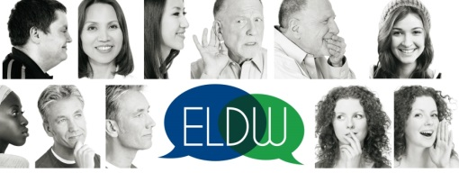
EUROPEAN LOCAL DEMOCRACY WEEK

Application form for “Partner of the ELDW”

2021 edition

“Protecting the environment: Local communities take action”

FORM TO BE COMPLETED AND RETURNED BEFORE 10 DECEMBER 2021 to democracy.week@coe.int

Name of the municipality:

Name of the Mayor ……………………………………………………………….
Address:
Country:
Website:
ELDW editions in which you participated in:

Contact person:
NAME, first name:
Fonction :
Phone number:
-E-mail :

- What are your motivations to request the Partner of the ELDW title?

- Did your municipality allocate a specific budget for citizens’ participation (including the ELDW activities)? Describe

- Did you carry out several specific activities linked to the leading theme of the year? Describe

- Did you organise an event with a pan-European dimension?

- How do you consider your activities as inclusive? Did they reach out different groups of citizens and minorities/ underrepresented groups (children, women, Roma and Travellers, people with a disability, migrants, etc.)?

- How did you promote the engagement of young people and youth organisations?

- To what extent are the implemented initiatives sustainable?

- In what way are your initiatives innovative?

Optional questions

- Did you name a personality with local influence as « Voice of the ELDW » (Name and function) to promote the initiative?

- Have you used the ELDW network to share knowledge, experience and good practices with other municipalities? If yes, with which municipalities and on which topic?

Appendix to attach if available

- allocated budget for the ELDW activities
- pictures that show the promotion of the ELDW made during the activities (visual identity) and events
- impact assessment on the initiatives

We kindly remind the applicants that all their activities should be uploaded and described under their municipality profile on the ELDW website.

